Batch: B2 Roll No.: 16010121200

Experiment / assignment / tutorial No. 10

Grade: AA / AB / BB / BC / CC / CD /DD

Signature of the Staff In-charge with date

Experiment No.: 10

TITLE: Study of Packet Analyzer tool: Wireshark

AIM: To study and analyse various Protocols using Packet Analyzer tool: Wireshark
_____________________________________________________________________________
Expected Outcome of Experiment:
CO:
_____________________________________________________________________________
Books/ Journals/ Websites referred:
- A. S. Tanenbaum, “Computer Networks”, Pearson Education, Fourth Edition
- B. A. Forouzan, “Data Communications and Networking”, TMH, Fourth Edition
_____________________________________________________________________________
Pre Lab/ Prior Concepts:
IPv4 Addressing, Subnetting, Link State Protocol, Router configuration Commands
_____________________________________________________________________________
New Concepts to be learned: Packet Analyzer tool: Wireshark.

THEORY:
Wireshark is a software tool used to monitor the network traffic through a network interface. It is the most widely used network monitoring tool today. Wireshark is loved equally by system administrators, network engineers, network enthusiasts, network security professionals and black hat hackers.
Wireshark has a rich feature set which includes the following:
- Deep inspection of hundreds of protocols, with more being added all the time
- Live capture and offline analysis
- Standard three-pane packet browser
- Multi-platform: Runs on Windows, Linux, macOS, Solaris, FreeBSD, NetBSD, and many others
- Captured network data can be browsed via a GUI, or via the TTY-mode TShark utility
- The most powerful display filters in the industryRich VoIP analysis
- Capture files compressed with gzip can be decompressed on the fly
- Live data can be read from Ethernet, IEEE 802.11, PPP/HDLC, ATM,
- Bluetooth, USB, Token Ring, Frame Relay, FDDI, and others (depending on
- your platform)
- Decryption support for many protocols, including IPsec, ISAKMP, Kerberos, SNMPv3, SSL/TLS, WEP, and WPA/WPA2
- Coloring rules can be applied to the packet list for quick, intuitive analysis
- Output can be exported to XML, PostScript®, CSV, or plain text

IMPLEMENTATION:
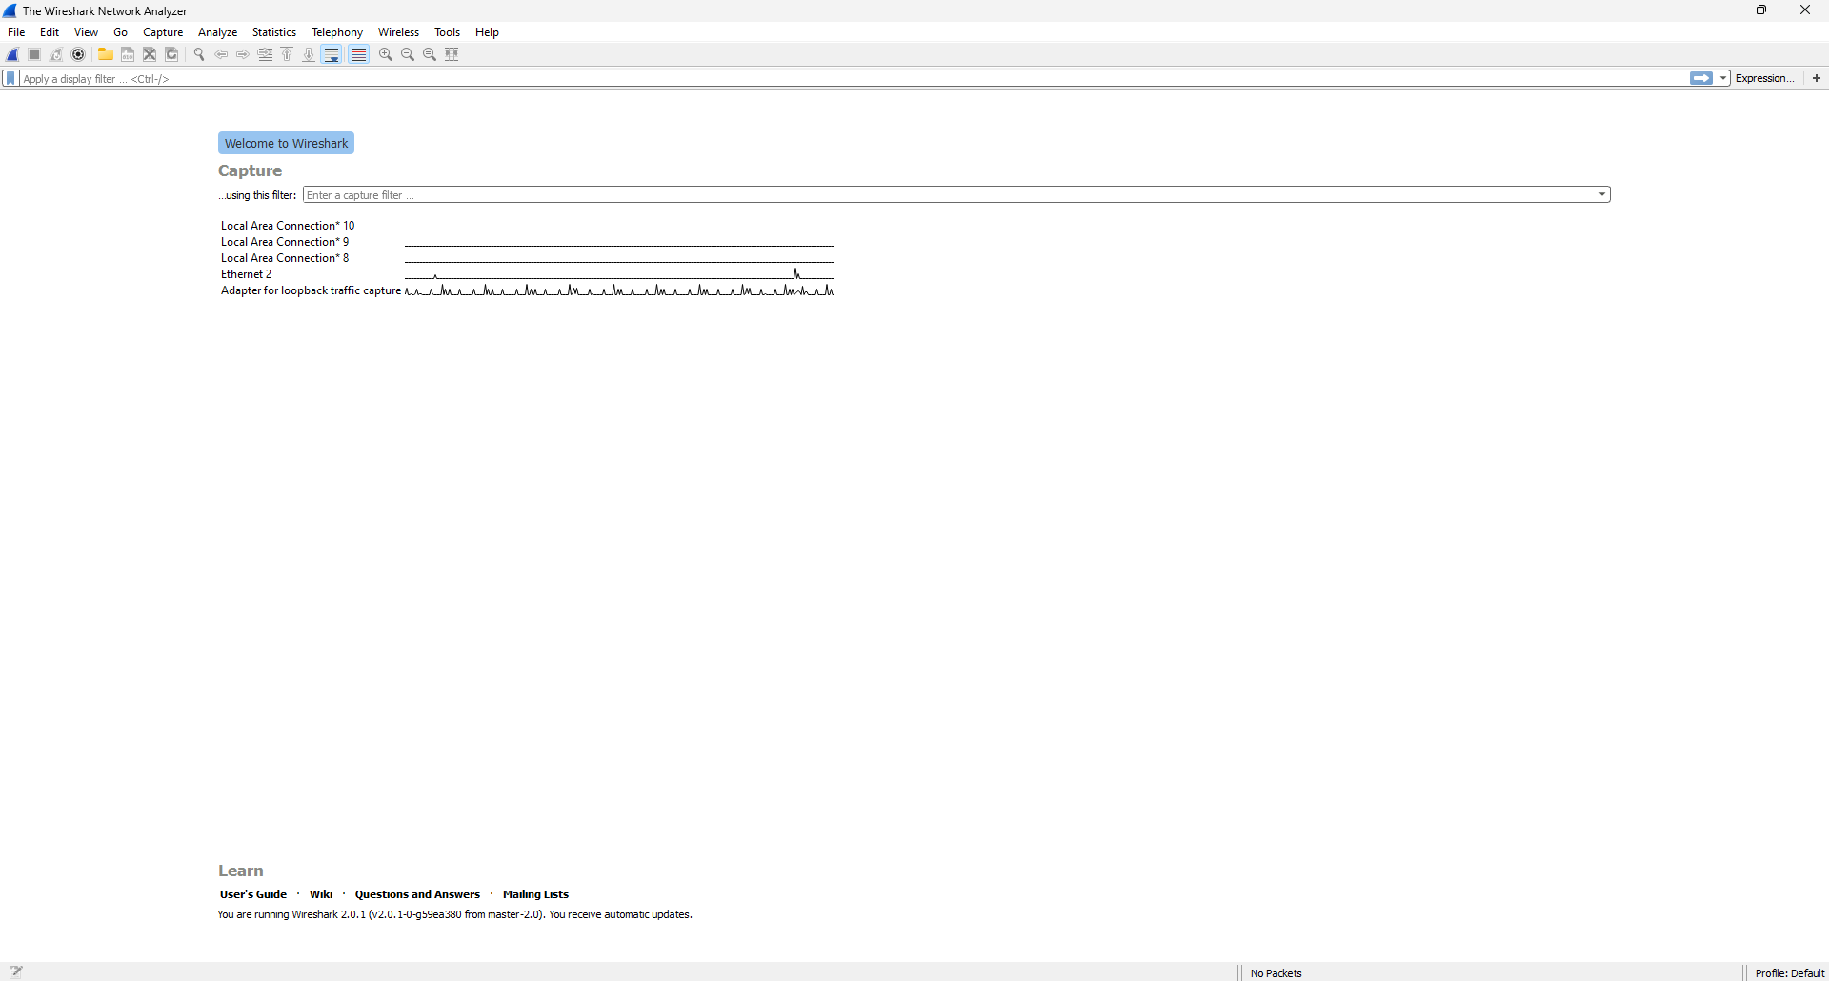

No filters:
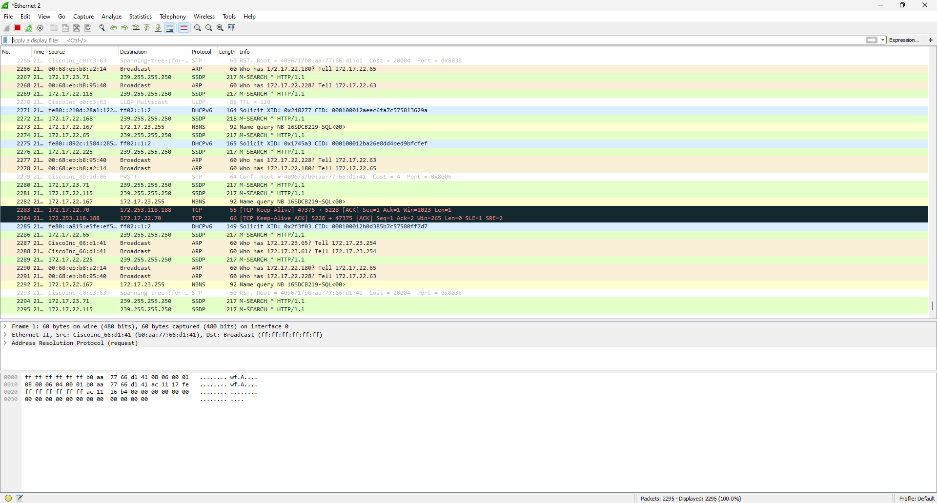

Capture filter:
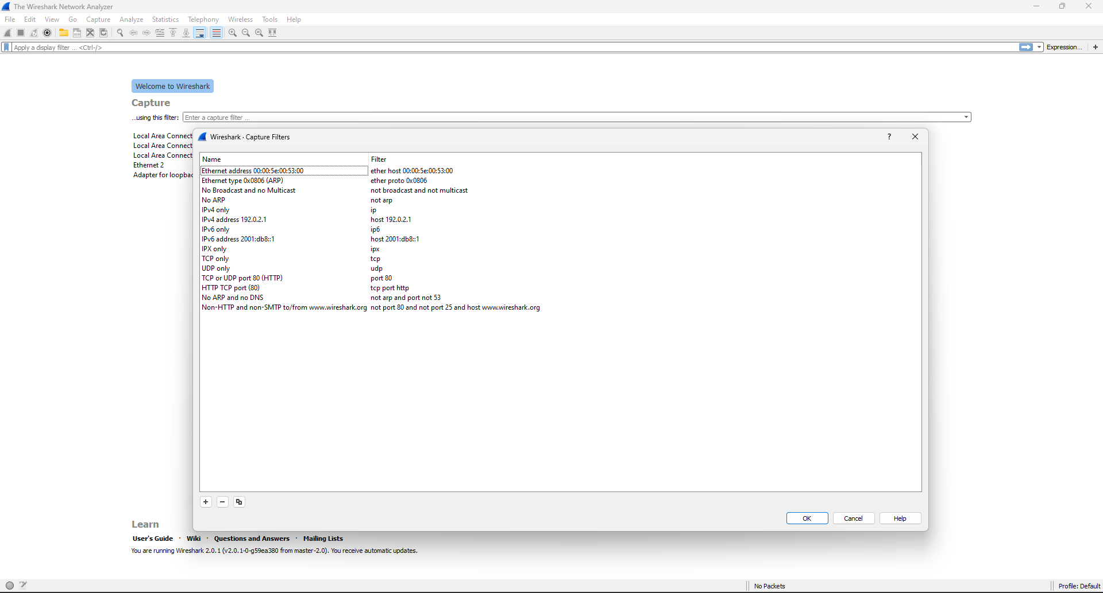

Capture from Ethernet 2
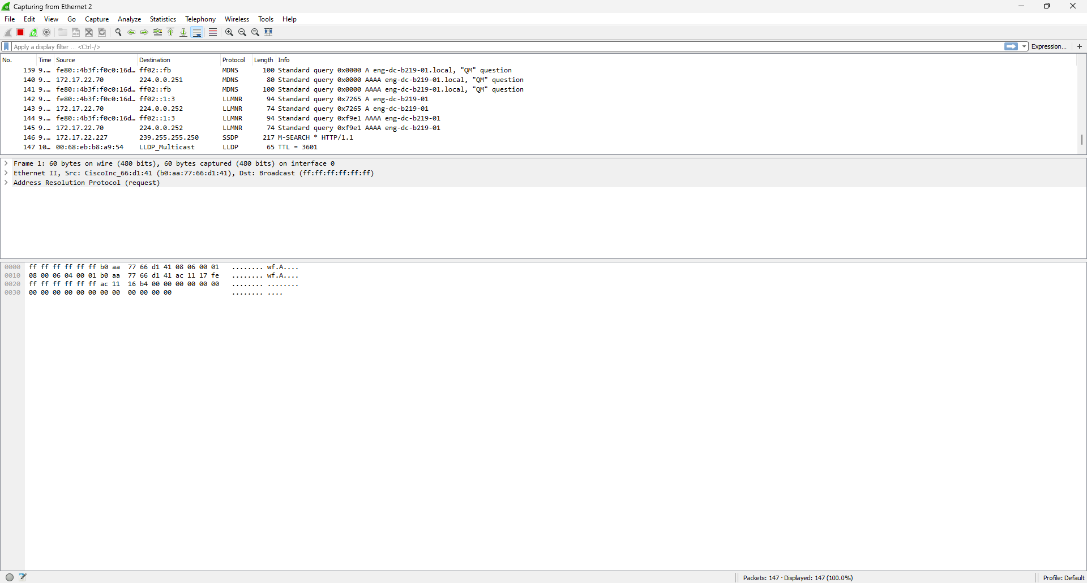

ARP Protocol:
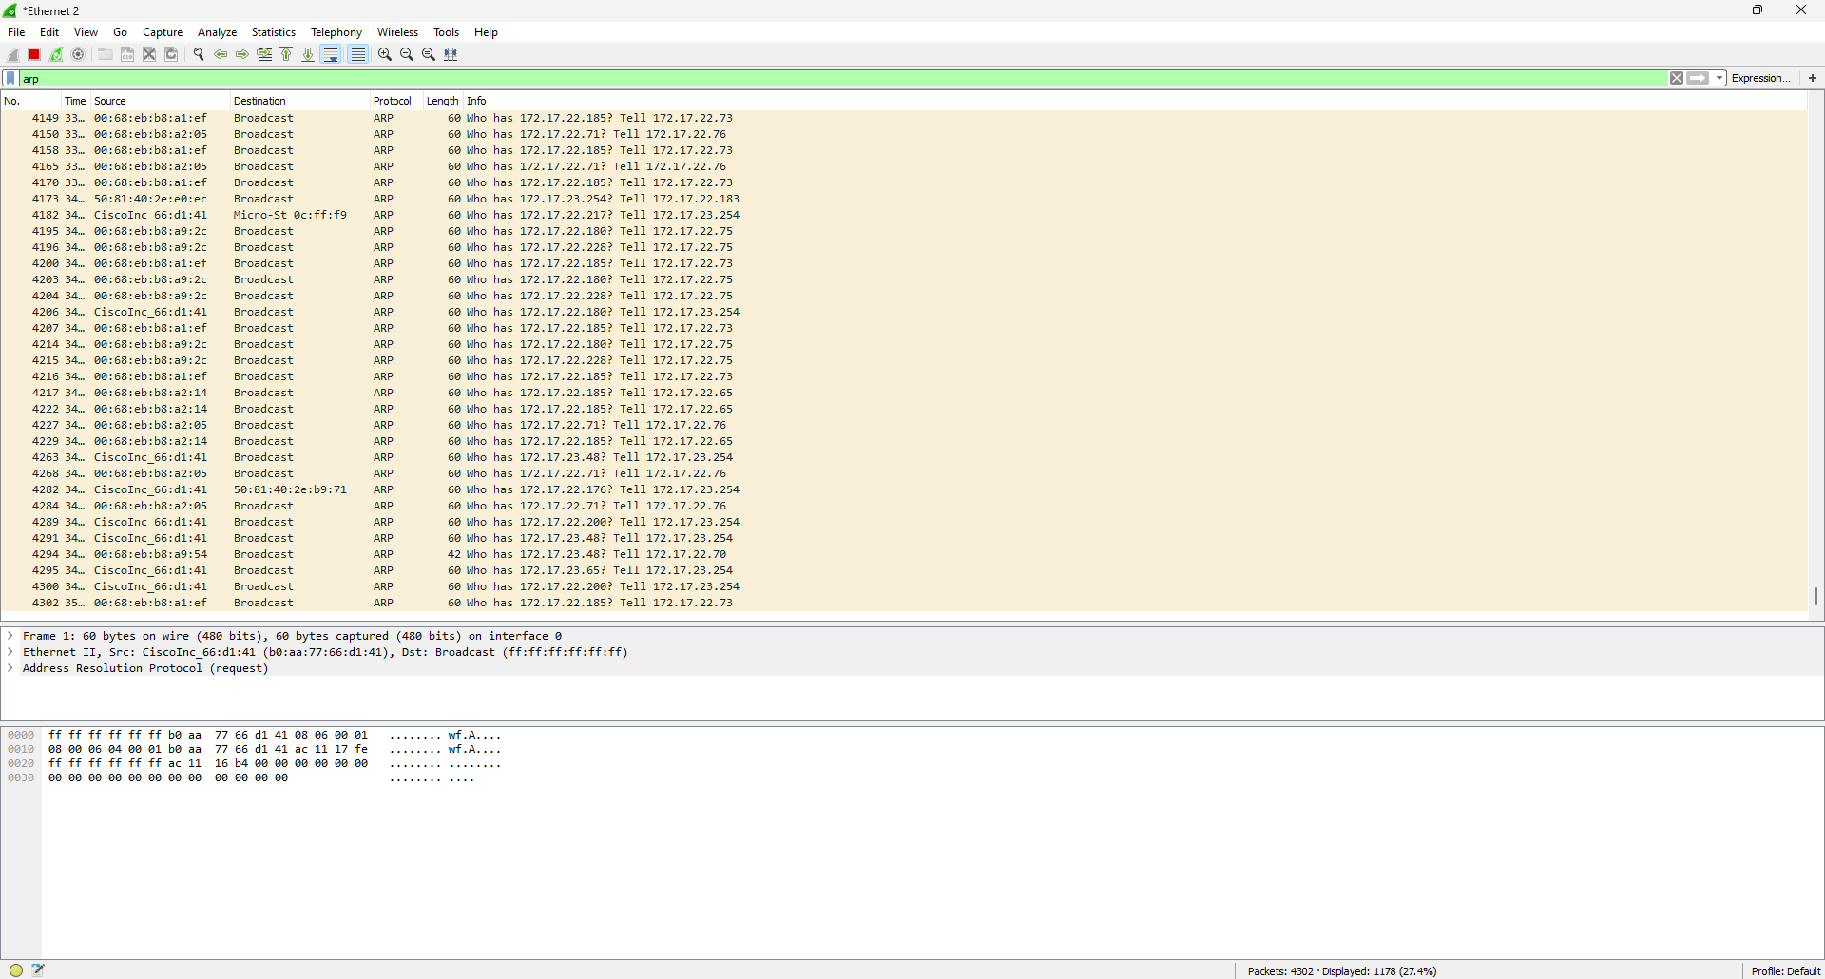

HTTP Protocol:
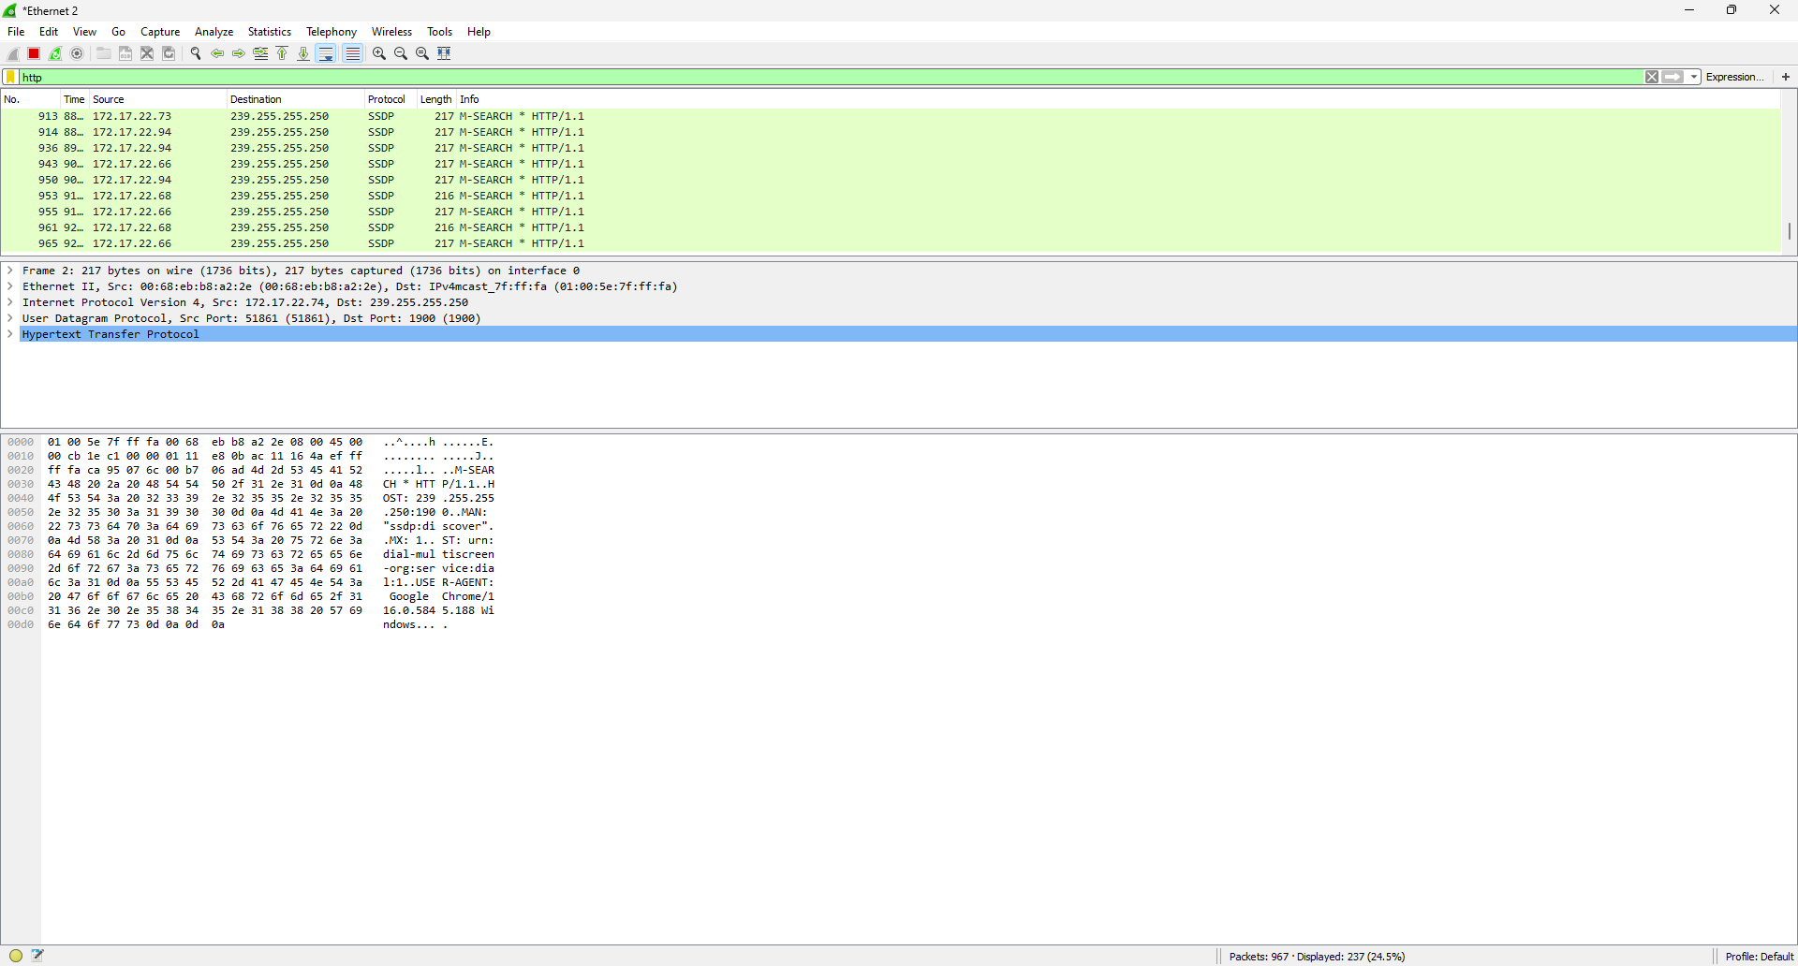

TCP Protocol:
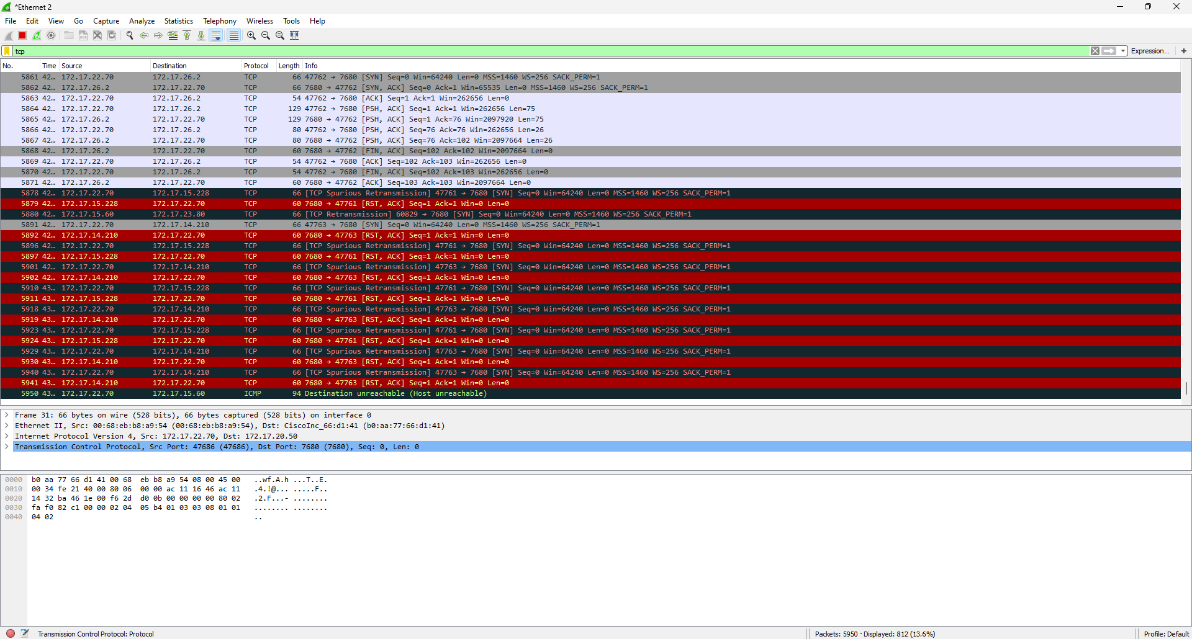

MNDP Protocol:
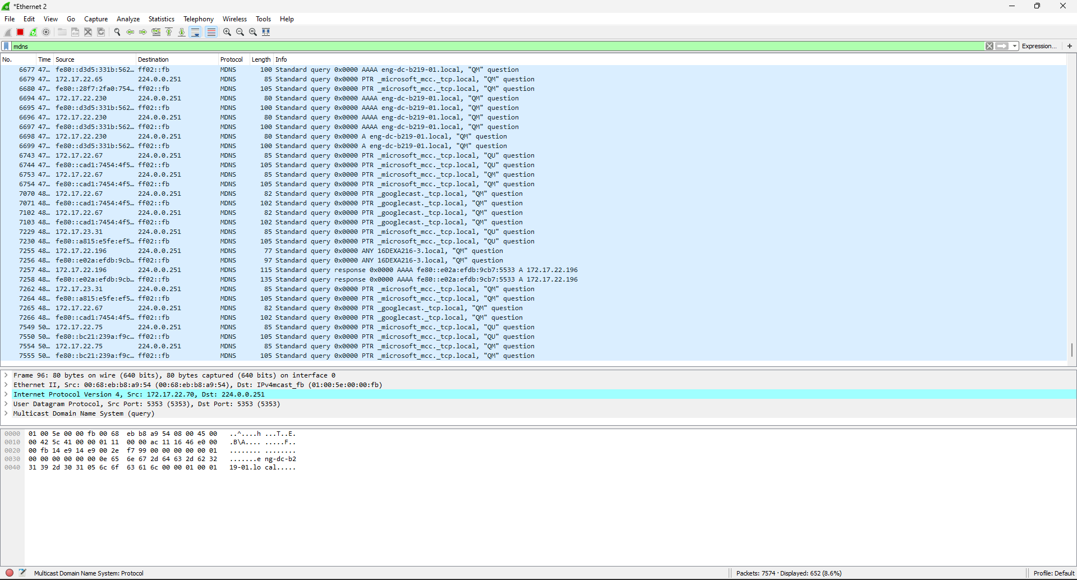

CONCLUSION:
Explored the wireshark software, tracked the data packets from the browser using ARP, HTTP, TCP, MNDP protocols.

Date: 16/10/2023 Signature of faculty in-charge

